A Report on

**Arduino Based Project Titled**

**Dual Axis Solar Tracker**

for

**Mini Project 1-B (REV- 2019 ‘C’ Scheme) of Second Year, (SE Sem-IV)**

in

**Electronics & Telecommunication Engineering**

by

1.B02 Divya Mokal

2.B14 Aditi Patil

3.B15 Kanchan Patil

4.B20 Tejas Pote

Under the guidance of

**Prof. Ruchira Patole**



**UNIVERSITY OF MUMBAI**

**A. Y. 2020-21**

|  | **Mahatma Education Society’s**  **Pillai College of Engineering**  **Accredited A+ by NAAC**  **Dr. K. M. Vasudevan Pillai Campus,**  **Plot No. 10, Sector-16, New Panvel - 410206** |
| --- | --- |

**CERTIFICATE**

This is to certify that the Arduino based project entitled **Dual Axis Solar Tracker** is a bonafide work of

1. B-02 Divya Mokal

2. B-14 Aditi Patil

3. B-15 Kanchan Patil

4. B-20 Tejas Pote

submitted to the University of Mumbai in partial fulfillment of the requirement for the award of **Mini Project 1-B (REV- 2019 ‘C’ Scheme) of Second Year, (SE Sem-IV)** in **Electronics & Telecommunication Engineering** as laid down by **University of Mumbai** during academic year **2020-21**

| (_____________________) | (_____________________) |
| --- | --- |
| **Examiner/Reviewer-1** | **Examiner/ Reviewer -2** |

|  |  |  |
| --- | --- | --- |
| **Name of Guide** | **Dr. Avinash Vaidya** | **Dr. Sandeep Joshi** |
| **Guide** | **Head of Department** | **Principal** |

**ABSTRACT**

Population of the world is increasing very rapidly. From the past decade, the non renewable energy sources like coal and oil are exhausting and so it has become a serious problem for providing reliable energy to the world. But solar energy plays an important source of primary energy.

In this project, we propose a dual axis solar tracking system by which it is possible to catch the maximum amount of solar energy by using Arduino as the main processing unit.The Arduino is used to give command to rotate the solar panel. Solar trackers are used to improve the power gain from solar energy. Solar power changes due to the seasonal variation and tilting of earth which changes the position of the sun in the sky. As a result of which we get a more efficient system which is compact, low cost as well as easy to use.

The use of solar trackers can increase electricity production by around a third, and some claim by as much as 40% in some regions, compared with modules at a fixed angle. In any solar application, the conversion efficiency is improved when the modules are continually adjusted to the optimum angle as the sun traverses the sky. Thus, the proposed solar tracker automatically tracks the sun to grab maximum solar power with the help of an Arduino board.

.

**LIST OF FIGURES**

| **Figure No.** | **Name of the figure** | **Page No.** |
| --- | --- | --- |
| 1.1 | Solar potential of India | 2 |
| 4.1 | Block Diagram | 6 |
| 4.2 | Circuit Diagram | 7 |
| 5.1 | Arduino UNO | 9 |
| 5.2 | LDR | 9 |
| 5.3 | Servo Motor | 10 |
| 5.4 | Proteus Software | 11 |
| 5.5 | Arduino IDE | 12 |
| 6.1 | Schematic diagram of the circuit | 13 |
| 7.1 | Simulation result of case 1 | 14 |
| 7.2 | Simulation result of case 2 | 15 |
| 7.3 | Simulation result of case 3 | 16 |
| 7.4 | Simulation result of case 4 | 17 |

**LIST OF TABLES**

| **Table**  **No.** | **Table Title** | **Page No.** |
| --- | --- | --- |
| 5.1 | Components | 8 |

**LIST OF ABBREVIATIONS**

| GW | Giga Watts |
| --- | --- |
| MW | Mega Watts |
| PV | Photovoltaic |
| LDR | Light Dependent Resistor |
| IDE | Integrated Development Environment |
| PWM | Pulse Width Modulation |
| DC | Direct Current |
| AC | Alternate Current |

**INDEX**

| **CONTENTS** | | | | |
| --- | --- | --- | --- | --- |
| Certificate | | …………………………………………………………………... | | i |
| Abstract | | …………………………………………………………………... | | ii |
| List of Figures | | …………………………………………………………………... | | iii |
| List of Tables | | …………………………………………………………………... | | iv |
| Abbreviation | | …………………………………………………………………... | | v |
|  | |  | |  |
| 1. | Introduction ………………………………………………………………….  1.1 Background  1.2 Solar Power in India | | | 1 |
| 2. | Literature Review……………………………………………………………. | | | 3 |
| 3. | Problem Statement …………………………………………………………..  3.1 Need  3.2 Objectives | | | 4 |
| 4. | Principle and Working ………………………………………………………  4.1 Block diagram  4.2 Circuit diagram | | | 6 |
| 5. | Component Description ……………………………………………………..  5.1 Hardware  5.2 Software | | | 8 |
| 6. | Software Implementation …………………………………………………… | | | 13 |
| 7. | Simulation Results ………………………………………………………….. | | | 14 |
| 8. | Conclusions …………………………………………………………………. | | | 18 |
| 9. | Future Scope ………………………………………………………………... | | | 19 |
| References | | | …………………………………………………………………... | 20 |
| Appendix | | | …………………………………………………………………... | 21 |

**CHAPTER 1.**

**INTRODUCTION**

This chapter gives a basic introduction about the background and solar power in India.

* 1. **BACKGROUND:**

When it comes to the development of any nation, energy is the main driving factor.There is an enormous quantity of energy that gets extracted, distributed, converted and consumed every single day in the global society.The world population is increasing day by day and the demand for energy is increasing accordingly. Oil and coal are the main source of energy nowadays but there is a fact that the fossil fuels are limited and hand strong pollution.Even the price of petroleum has been increasing year by year and the provisions on the medium term there are not quite encouraging. Utilization of these resources increases the emission of carbon monoxide, Nitrogen Oxides and Sulphur Oxides which are responsible for global warming and greenhouse effect. This results in a devastating effect in the environment.

1. **SOLAR POWER IN INDIA:**

Solar power in India is a fast developing industry. The country's solar installed capacity was 36.9 GW as of 30 November 2020. The Indian government had an initial target of 20 GW capacity for 2022, which was achieved four years ahead of schedule.In 2015 the target was raised to 100 GW of solar capacity (including 40 GW from rooftop solar) by 2022, targeting an investment of US$100 billion. India has established nearly 42 solar parks to make land available to the promoters of solar plants. Rooftop solar power accounts for 2.1 GW, of which 70% is industrial or commercial.In addition to its large-scale grid-connected solar photovoltaic (PV) initiative, India is developing off-grid solar power for local energy needs. Solar products have increasingly helped to meet rural needs; by the end of 2015 just under one million solar lanterns were sold in the country, reducing the need for kerosene. That year, 118,700 solar home lighting systems were installed and 46,655 solar street lighting installations were provided under a national program; just over 1.4 million solar cookers were distributed in India. The 125-MW Sakri solar plant is the largest solar-power plant in Maharashtra. The Shri Saibaba Sansthan Trust has the world's largest solar steam system. It was constructed at the Shirdi shrine at an estimated cost of ₹1.33 crore (US$190,000), ₹58.4 lakh (US$82,000) which was paid as a subsidy by the renewable-energy ministry. The system is used to cook 50,000 meals per day for pilgrims visiting the shrine, resulting in annual savings of 100,000 kg of cooking gas, and was designed to generate steam for cooking even in the absence of electricity to run the circulating pump. The project to install and commission the system was completed in seven months, and the system has a design life of 25 years. The Osmanabad region in Maharashtra has abundant sunlight, and is ranked the third-best region in India in solar insolation. A 10 MW solar power plant in Osmanabad was commissioned in 2013. The total power capacity of Maharashtra is about 500 MW[1].

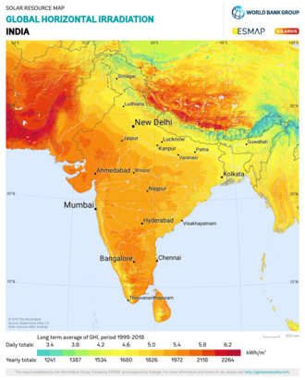

**Fig 1.1 Solar potential of India**

**CHAPTER 2.**

**LITERATURE REVIEW**

Hossein Mousazadeh et Al.,(2011), Journal of Solar Energy Engineering,Vol.133, studied and investigated maximization of collected energy from an on-board PV array, on a solar assist plug-in hybrid electric tractor (SAPHT). Using four light dependent resistive sensors a sun-tracking system on a mobile structure was constructed and evaluated. The experimental tests using the sun-tracking system showed that 30% more energy was collected in comparison to that of the horizontally fixed mode. Four LDR sensors were used to sense the direct beams of the sun. Each pair of LDRs was separated by an obstruction as a shading device. A microcontroller based electronic drive board was used as an interface between the hardware and the software. For driving of each motor, a power MOSFET was used to control the actuators. The experimental results indicated that the designed system was very robust and effective[3].

K.S. Madhu et al., (2012) International Journal of Scientific & Engineering Research vol. 3, 2229–5518, states that a single axis tracker tracks the sun east to west, and a two-axis tracker tracks the daily east to west movement of the sun and the seasonal declination movement of the sun. Concentrates solar power systems use lenses or mirrors and tracking systems to focus a large area of sunlight into a small beam. PV converts light into electric current using the photoelectric effect. Solar power is the conversion of sunlight into electricity. Test results indicate that the increase in power efficiency of tracking solar plates on normal days is 26 to 38% compared to fixed plates. And during cloudy or rainy days it varies at any level[3].

**CHAPTER 3.**

**PROBLEM STATEMENT**

Looking at the present situation and the major shift towards digitalization and the progressing population of India, there is an increase in electricity consumption and thus there is a need for alternatives or solutions. Solar energy is the best solution for this problem. Solar energy is renewable energy which is obtained from the sun. Due to increased global warming and depletion of fossil fuels, many industries and households are opting for solar panels.The problem here is that the solar panel has only fixed installation. Because of this problem, the power that can be generated is low. The other problem is the price for the solar tracking system is very expensive for the family that uses more power than usual because it needs to install more than one solar panel to produce enough power. The other problem is that the fixed solar panels do not aim directly to the sun due to the constant motion of earth. As a result the power produced is not maximum. The better solution for this system to get maximum output power is a solar tracking system. This is the main reason the project dual axis solar tracker is made. So this project is to fix the problem that occurs. This solar tracking system can detect a 180 degree of rotation. So the solar panel that can be generating here is very high compared to when the solar panel can only stay in one direction.y

1. **NEED**

Solar energy is a universally accepted renewable energy source, which can be used to avoid the energy crisis. In order to maximize energy generation from the sun, it is necessary to introduce solar tracking systems into solar power systems.Solar trackers are devices used to orient photovoltaic panels, reflectors, lenses or other optical devices toward the sun. Since the sun's position in the sky changes with the seasons and the time of day, trackers are used to align the collection system to maximize energy production. A dual-axis tracker can increase energy by tracking sun rays from switching solar panels in various directions. This solar panel can rotate in all directions. It is an eco-friendly method of utilising solar energy for maximum energy consumption is dual axis solar tracker.

* To provide a maximum efficiency
* Commercial purpose
* Increase solar panel output
* Able to grab the energy throughout the day.

1. **OBJECTIVES**

* To develop a tracking system that constantly tracks the sun during daytime.
* To develop a tracking system that maximizes the solar panel power generation.
* To develop a tracking system based on LDR..
* To develop a tracking system that control and monitor the movement of solar panel based on the intensity of light
* To increase the total efficiency of a solar system.
* To design and construct an automatic solar tracking system where this system will align and orientate the position of the solar panel according to light intensity falling on it.

**CHAPTER 4.**

**PRINCIPLE AND WORKING**

Solar tracker, a system that positions an object at an angle relative to the sun. The most-common applications for solar trackers are positioning solar panels so that they remain perpendicular to the sun’s rays and can determine the sun’s direction properly. Solar trackers adjust the direction that a solar panel is facing according to the position of the Sun in the sky. By keeping the panel perpendicular to the sun, more sunlight strikes the solar panel, less light is reflected, and more energy is absorbed. That energy can be converted into power.

In this project, we make a dual-axis solar tracker with an arduino, 4 LDRs, 100k resistors, and 2 servo motors. Dual-axis trackers continually face the sun because they can move in two different directions. Types include tip-tilt and azimuth-altitude. Dual-axis tracking is typically used to orient a mirror and redirect sunlight along a fixed axis towards a stationary receiver. Because these trackers follow the sun vertically and horizontally they help obtain maximum solar energy generation at a time.

1. **BLOCK DIAGRAM**

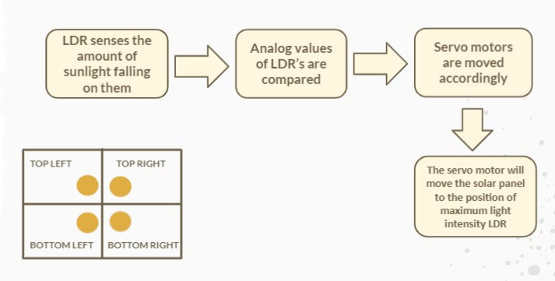

**Fig 4.1 Block diagram**

The fig 4.1. shows the block diagram of the dual axis solar tracker system. It consists of Arduino, LDR, Resistor, Servo motor. In this project, we are using 4 LDRs to detect the Sunlight. And when they send a signal to the Arduino, it will guide two Servo Motors to better place the solar panel to maximize its efficiency.

1. **CIRCUIT DIAGRAM**

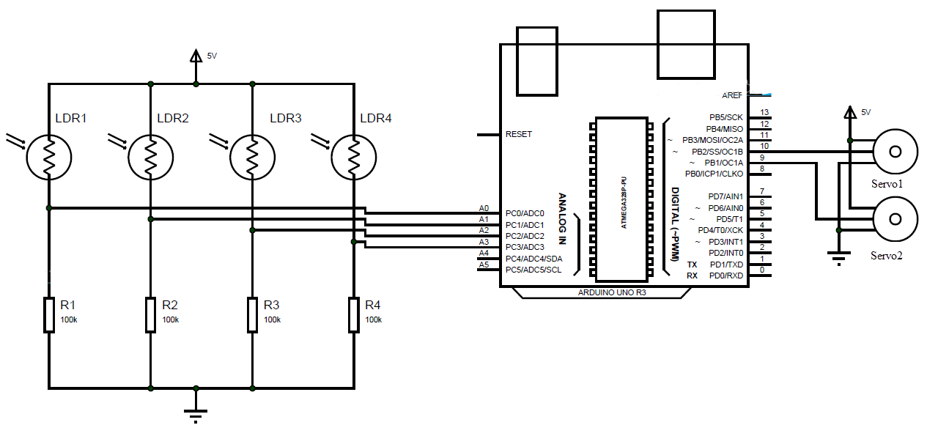

**Fig 4.2 Circuit diagram**

Fig 4.2 shows circuit for moving the solar tracker. The dual axis solar tracker has been conducted starting from simulation testing by using Proteus Software.The software used to design simulation circuits to testing the movement mechanism of this project. On this part the movement and rotation of the solar tracker will be tested to find out the system in the right order. Fig 4.1 shows the flowchart of movement of the solar tracker. When the power supply is supplied to the circuit, it will turn on the Arduino UNO and servo motor. The Arduino used as the main processor unit and servo motor used as the hardware component to rotate the solar tracker. This project uses two 180 degree angles servo motors which are horizontal and vertical. Starting from four sensors that detect the position of the sun. The data that has been received from the sensor will convert the analog data to digital data and the data will be read in Arduino UNO to make a comparison for position of the solar panel directly toward the sun ray. The system will analyze the data in order to determine the direction of the sun and make horizontal and vertical servo motors move according to the command that has been set in Arduino IDE. The servo motor will be operated according to the LDR sensor that has been detecting the sun ray.

**CHAPTER 5.**

The circuit diagram for this project can be referred from Fig. 4.1 and 4.2 which gives an overview of how the connections of the necessary components are made so as to achieve dual axis solar tracker to get maximum solar energy and make a system which is more efficient and compact, cost effective as well as easy to use.

This chapter gives information about the components and software used in our project.

**COMPONENT DESCRIPTION**

**Table 5.1 Components**

| **Sr No.** | **Name of the component** | **Value** |
| --- | --- | --- |
| 1. | Arduino | Arduino Uno |
| 2. | LDR | Four |
| 3. | Resistor | Four 10kΩ |
| 4. | Servo Motor | Two 4.8-6V |

Table 5.1 shows the components used in our project. Below are some of the major components used:

**ARDUINO UNO :**

The Arduino Uno is an open-source microcontroller board based on the Microchip ATmega328P microcontroller and developed by Arduino.cc. The board is equipped with sets of digital and analog input/output (I/O) pins that may be interfaced to various expansion boards (shields) and other circuits. The board has 14 digital I/O pins (six capable of PWM output), 6 analog I/O pins, and is programmable with the Arduino IDE (Integrated Development Environment), via a type B USB cable. It can be powered by the USB cable or by an external [9-volt](https://en.wikipedia.org/wiki/9-volt_battery) battery, though it accepts voltages between 7 and 20 volts.

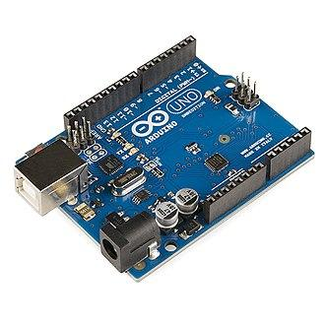

**Fig 5.1 Arduino UNO**

**LDR :**

Photo resistors, also known as light dependent resistors (LDR), are light sensitive devices most often used to indicate the presence or absence of light, or to measure the light intensity. In the dark, their resistance is very high, sometimes up to 1MΩ, but when the LDR sensor is exposed to light, the resistance drops dramatically, even down to a few [ohms](https://eepower.com/resistor-guide/resistor-fundamentals/ohms-law/), depending on the light intensity. LDRs have a sensitivity that varies with the wavelength of the light applied and are nonlinear devices.

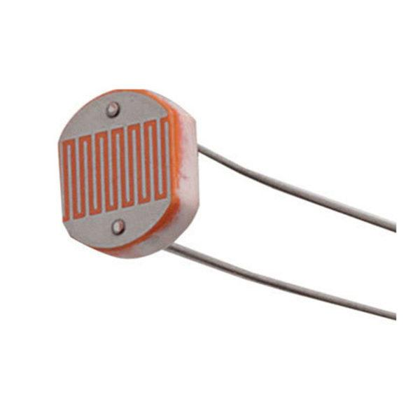

**Fig 5.2 LDR**

**SERVO MOTOR:**

A servo motor is a type of motor that can rotate with great precision. Normally this type of motor consists of a control circuit that provides feedback on the current position of the motor shaft, this feedback allows the servo motors to rotate with great precision. If you want to rotate an object at some specific angles or distance, then you use a servo motor. It is just made up of a simple motor which runs through a servo mechanism. If a motor is powered by a DC power supply then it is called DC servo motor, and if it is AC-powered motor then it is called AC servo motor.

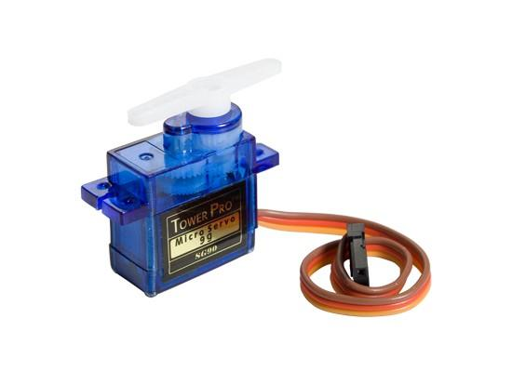

**Fig 5.3 Servo Motor**

**5.1 HARDWARE**

NO Hardware

**5.2 SOFTWARE**

**5.2.1 PROTEUS:**

For our project, we have used Proteus and Arduino IDE for simulation. The Proteus Design Suite is a proprietary software tool suite used primarily for electronic design automation. It is developed in Yorkshire, England by Labcenter Electronics Ltd with offices in North America and several overseas sales channels. The software runs on the Windows operating system and is available in English, French, Spanish and Chinese languages.

The first version of what is now the Proteus Design Suite was called PC-B and was written by the company chairman, John Jameson, for DOS in 1988. Schematic Capture support followed in 1990, with a port to the Windows environment shortly thereafter. Mixed mode SPICE Simulation was first integrated into Proteus in 1996 and microcontroller simulation then arrived in Proteus in 1998. Shape based auto routing was added in 2002 and 2006 saw another major product update with 3D Board Visualization. More recently, a dedicated IDE for simulation was added in 2011 and MCAD import/export was included in 2015. Feature led product releases are typically biannual, while maintenance-based service packs are released as required.

The Proteus Design Suite is a Windows application for schematic capture, simulation, and PCB layout design. It can be purchased in many configurations, depending on the size of designs being produced and the requirements for microcontroller simulation. All PCB Design products include an auto router and basic mixed mode SPICE simulation capabilities. The software is used mainly by electronic design engineers and technicians to create schematics and electronic prints for manufacturing printed circuit boards. The Proteus Design Suite is a Windows application for schematic capture, simulation, and PCB (Printed Circuit Board) layout design.

Schematic capture in the Proteus Design Suite is used for both the simulation of designs and as the design phase of a PCB layout project. It is therefore a core component and is included with all product configurations. Proteus is a virtual system modelling and circuit simulation application. The suit combines mixed mode SPICE circuit simulation, animated components and microprocessor models to facilitate co-simulation of complete microcontroller-based designs.

The microcontroller simulation in Proteus works by applying either a hex file or a debug file to the microcontroller part on the schematic. It is then co-simulated along with any analog and digital electronics connected to it. This enables it's used in a broad spectrum of project prototyping in areas such as motor control, temperature control and user interface design. It also finds use in the general hobbyist community and, since no hardware is required, is convenient to use as a training or teaching tool.

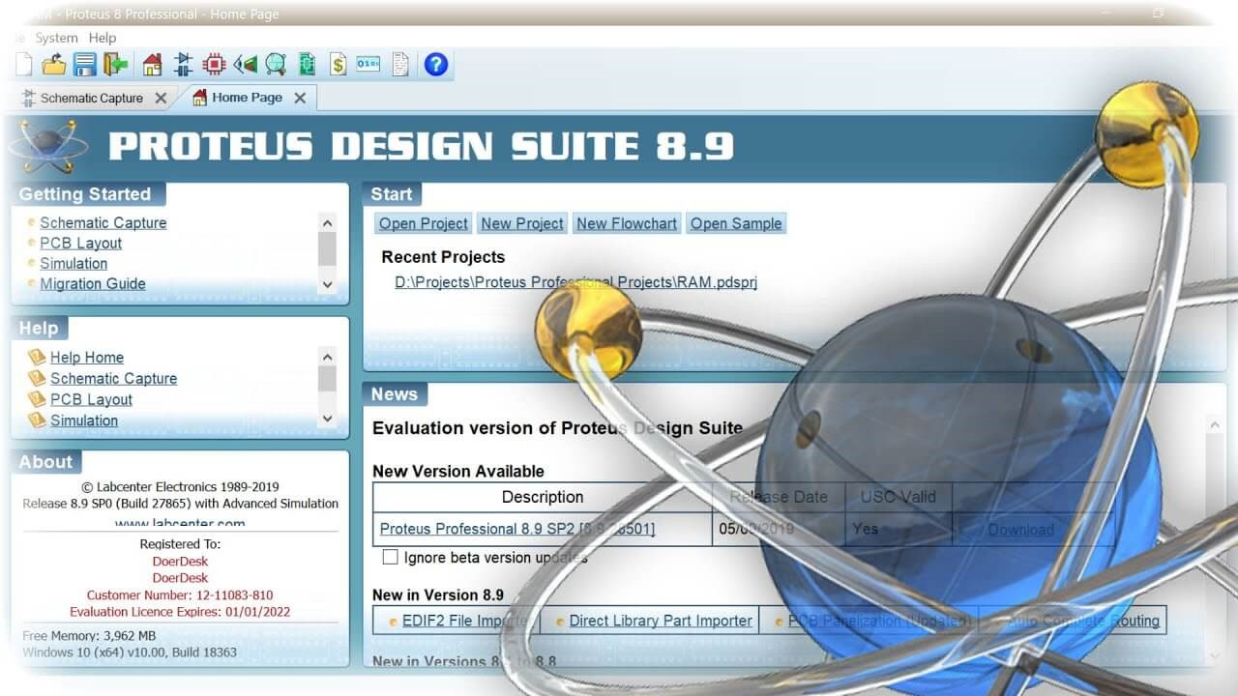

**Fig 5.4 Proteus Software**

**5.2.2 ARDUINO IDE:**

For our project, we have used Arduino IDE for writing the source code and creating a hex file to upload in Proteus.The Arduino Integrated Development Environment ([IDE](https://en.wikipedia.org/wiki/Integrated_development_environment)) is a [cross-platform](https://en.wikipedia.org/wiki/Cross-platform) application (for [Windows](https://en.wikipedia.org/wiki/Windows), [macOS](https://en.wikipedia.org/wiki/MacOS), [Linux](https://en.wikipedia.org/wiki/Linux)) that is written in functions from [C](https://en.wikipedia.org/wiki/C_(programming_language)) and [C++](https://en.wikipedia.org/wiki/C%2B%2B_(programming_language)). It is used to write and upload programs to [Arduino](https://en.wikipedia.org/wiki/Arduino) compatible boards, but also, with the help of third-party cores, other vendor development boards.

The source code for the IDE is released under the [GNU General Public License](https://en.wikipedia.org/wiki/GNU_General_Public_License), version 2.The Arduino IDE supports the languages [C](https://en.wikipedia.org/wiki/C_(programming_language)) and [C++](https://en.wikipedia.org/wiki/C%2B%2B) using special rules of code structuring. The Arduino IDE supplies a [software library](https://en.wikipedia.org/wiki/Software_library) from the [Wiring](https://en.wikipedia.org/wiki/Wiring_(development_platform)) project, which provides many common input and output procedures. User-written code only requires two basic functions, for starting the sketch and the main program loop, that are compiled and linked with a program stub main() into an executable [cyclic executive](https://en.wikipedia.org/wiki/Cyclic_executive) program with the [GNU toolchain](https://en.wikipedia.org/wiki/GNU_toolchain), also included with the IDE distribution. The Arduino IDE employs the program avrdude to convert the executable code into a text file in hexadecimal encoding that is loaded into the Arduino board by a loader program in the board's firmware. By default, avrdude is used as the uploading tool to flash the user code onto official Arduino boards.

Arduino IDE is a derivative of the [Processing IDE](https://en.wikipedia.org/wiki/Processing_(programming_language)), however as of version 2.0, the Processing IDE will be replaced with the [Visual Studio Code](https://en.wikipedia.org/wiki/Visual_Studio_Code)-based [Eclipse Theia](https://en.wikipedia.org/wiki/Eclipse_Theia) IDE framework.With the rising popularity of Arduino as a software platform, other vendors started to implement custom open source compilers and tools (cores) that can build and upload sketches to other [microcontrollers](https://en.wikipedia.org/wiki/Microcontroller) that are not supported by Arduino's official line of microcontrollers.

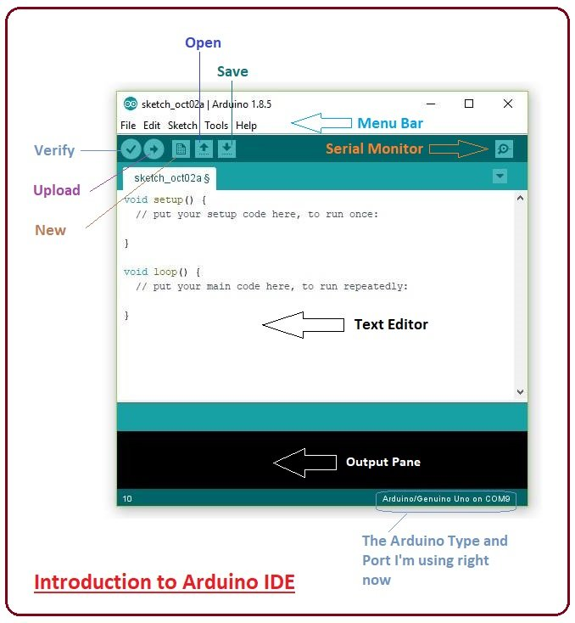

**Fig 5.5 Arduino IDE**

**CHAPTER 6.**

**SOFTWARE IMPLEMENTATION**

This chapter gives information about software implementation of our project.

Conventionally, the designing process requires only the estimation based on theoretical understanding. With the help of assisted software, simulation can be done. From this simulation result, it gives the guideline flexibility to refine the circuit for example the outcome or the result does not satisfy the requirement. For this project, Proteus software is used. This software not only helps to speed up the process of designing, but also avoid unnecessary mistakes before the actual thing is built.

Proteus simulation is a software tool that can design a schematic diagram and make a simulation of the circuit. It is easy to use this program because we can design our own circuit and simulate it. We can check if the simulations work properly or not and make changes accordingly. We made a circuit using a microcontroller and LDR. We had to add libraries for some missing components like Arduino UNO. We had to add the hex file which we generated using Arduino IDE. We assembled the components according to the circuit diagram shown in fig 6.1. After assembling the components and completing the circuit, we simulated the circuit to observe the results.

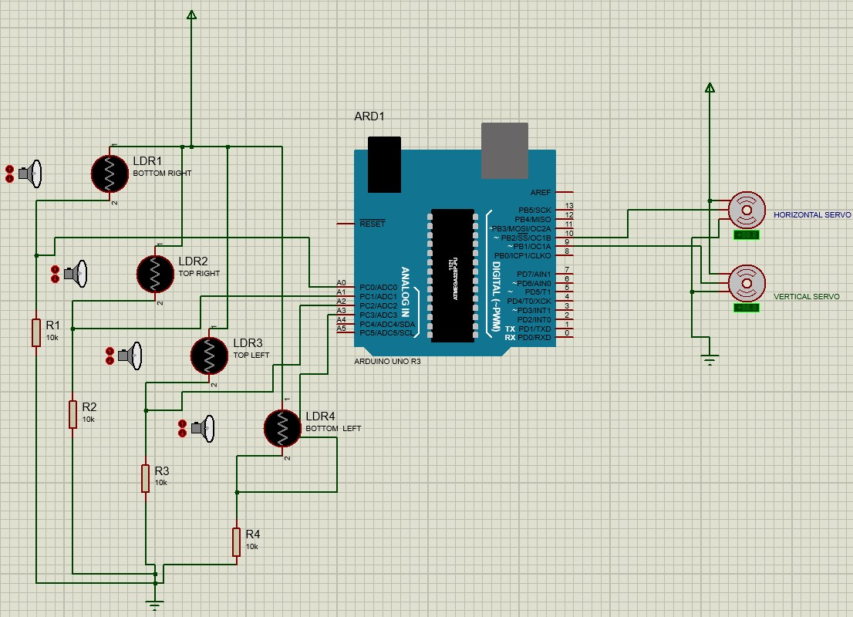

**Fig 6.1 Schematic diagram of the circuit**

**CHAPTER 7.**

**SIMULATION RESULTS**

This chapter shows the simulation results of our project.

When we power on the Arduino all the sensors and servo motors are into the action. Usually, when we increase the light intensity of the LDR sensor, the signal is sent to the arduino and hence it guides the two servo motors to better place the solar panels. There are 4 cases being simulated and at the same time there are 4 LDRs which are used as input sensors. Therefore, each of these sensors has its output voltage resulting from the voltage divider.

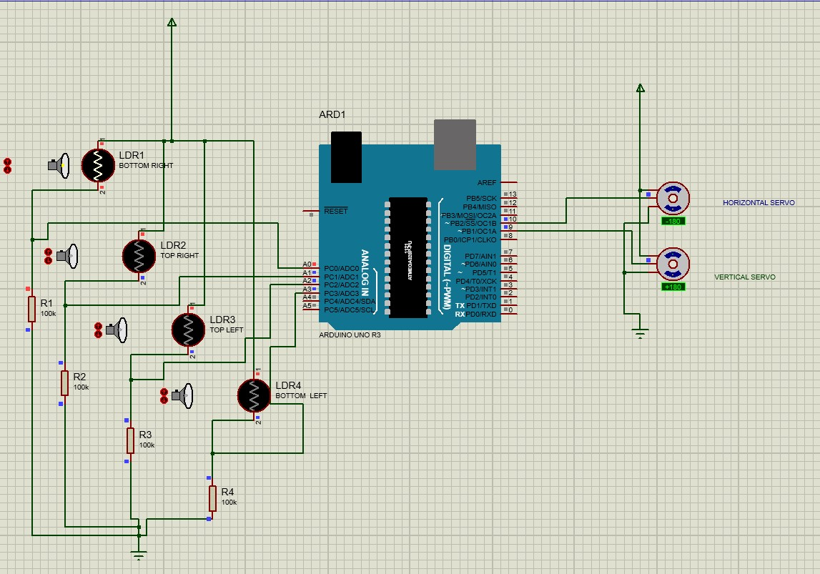

**Fig 7.1 Simulation result of case 1**

1. Case 1 is when the LDR1 is getting the light source in position 1 i.e. right and bottom(sun rising in the east direction) then the Arduino is getting the signal from the LDR1 and hence the Arduino will send the signal to both the servo motors. The vertical servo motor will rotate clockwise.

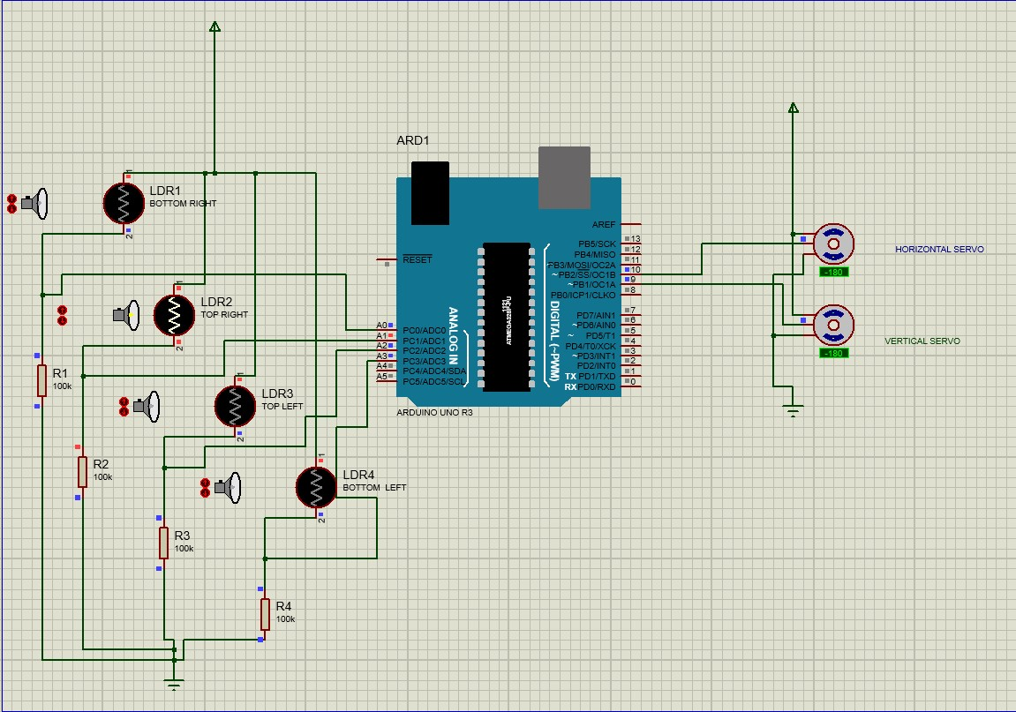

**Fig 7.2 Simulation results of case 2**

1. Case 2 is for position 2 which is right and top(sun rising in north-east direction), when LDR2 is getting the light source, the servo motor will turn anticlockwise. This is because of the coding that has been set in the software.

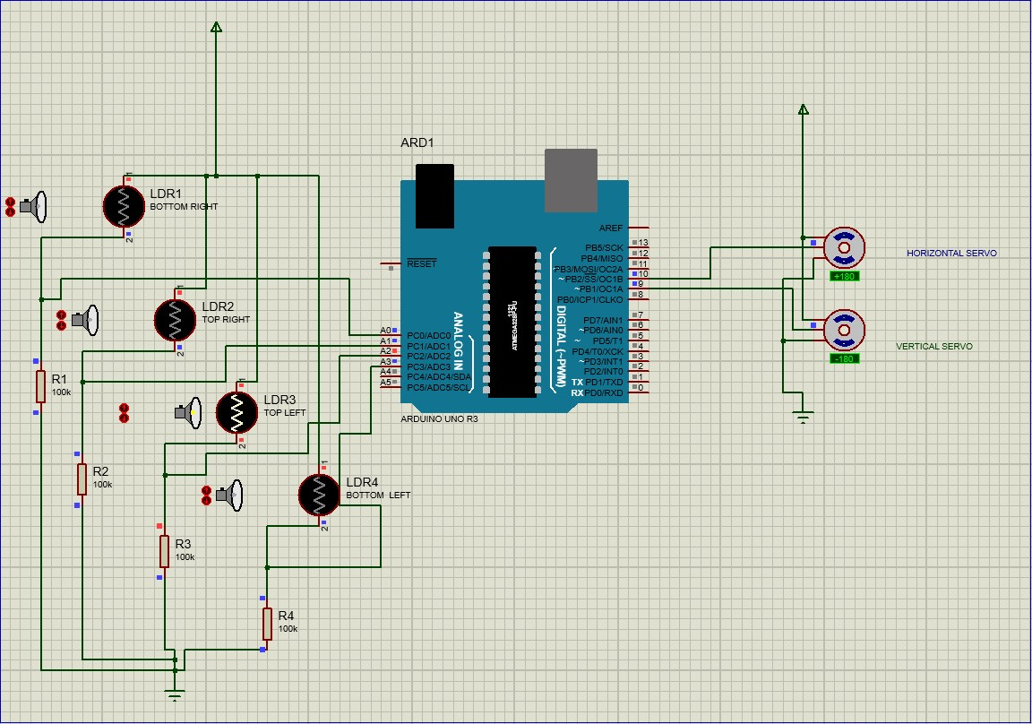

**Fig 7.3 Simulation result of case 3**

1. Case 3 is for position 3 which is left and top(sun rising in north-west direction), when LDR3 is getting a light source, the opposite will happen compared to position 1 i.e. the horizontal servo will rotate clockwise.

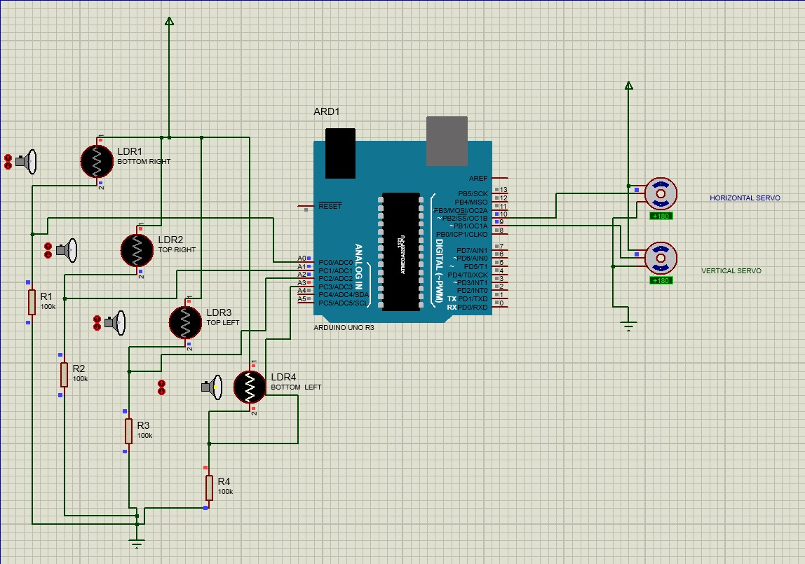

**Fig 7.4 Simulation result of case 4**

1. Case 4 is for position 4 which is left and bottom(sun is in west direction), when LDR4 is getting the light source, the opposite will be compared to position 2 i.e. the vertical servos will turn clockwise.

Now when the sun rises the next day in the east direction, for position 1 the horizontal servo motor will rotate clockwise and the rest will remain the same.

**CHAPTER 8.**

**CONCLUSIONS**

With Global Warming constantly affecting the world in numerous ways, it is essential we begin taking care of nature in whatever way possible. Present day technology stresses on being clean and green. Being environmentally friendly, solar power generators and panels are reasonably easy, safe and convenient to install. It will be able to reduce energy crises to a great extent with effective use of solar energy by means of tracking. The economically and environmentally friendly dual axis solar tracker also can be a great technique in utilizing the superiority of solar energy thus solving the increasing demand of electricity.

In this project, we presented a means of tracking the sun's position with the help of Microcontroller(Arduino Uno). Solar tracking system is more efficient than any other ordinary panel. It is possible to reduce the energy crisis to some large extent. It will be a good and competitive solution for the marketplace as it is expected to compete with more complex and expensive systems. Hence enhancing the solar powered systems with intelligent trackers proves to be the optimal solution for utilizing the available solar energy. So, the designed dual axis solar tracker is capable of tracking the sun throughout the year.

**CHAPTER 9.**

**FUTURE SCOPE**

This project is limited to optimisation of solar energy using a Arduino Uno based dual axis solar tracker. Fabrication of Microcontrollers using basic concepts: The number of wires can be greatly reduced by directly if a customized PCB is made upon which all the resistors can be directly soldered. This also eliminates the use of Breadboard which was used to make all the external connections. Mounting the panels: In this the panels are mounted on a horizontal shaft supported strongly at both ends. We can mount the panels directly onto a motor placed at the centre of the panel-base in order in order to provide east west movements.This reduces the weight and elective cost of the project.

Here are some of the following points can be made:

* Improving the mechanical structure
* Improving the load carrying capacity
* Putting solar panel with total system
* Adjusting the gear ratio to reduce energy loss

**REFERENCES**

1. www.en.wikipedia.org/wiki/Solar_power_in_India
2. Prabhas Baral, Shishir Bhusal,Nimesh Chhukan,Kamal Gautam,Kshitiz Koirala,”Design and fabrication of dual axis solar tracking system”,Kathmandu university school of engineering department of mechanical engineering
3. Syed Arsalan, “Sun Tracking System with Microcontroller 8051”, International Journal of Scientific & Engineering Research, Vol. 4, No. 6,pp. 2998-3001, June 2013
4. Muhammad Imam, Waqar Nawaz, Abdul Waheed, “Dual axis solar tracker”, Feas Riphah International University, Islamabad
5. Vinayak Kumar, Manpreet Kaur, Kunal Paul, Shiv Yadav, Manoj Kumar, ”Closed loop solar tracking system”
6. Neeraj Singh, “Performance of Dual Axis Solar Tracker”,Researchgate Publications, November 2017.
7. create.arduino.cc/projecthub/shashwatraj98765/how-to-make-dual-axis-solar-tracker
8. www.theiotprojects.com/dual-axis-solar-tracker-arduino-project-using-ldr-servo-motors/

**APPENDIX**

**SOURCE CODE :**

#include <Servo.h>

//defining Servos

Servo servohori;

int servoh = 0;

int servohLimitHigh = 160;

int servohLimitLow = 20;

Servo servoverti;

int servov = 0;

int servovLimitHigh = 160;

int servovLimitLow = 20;

//Assigning LDRs

int ldrtopl = 2; //top left LDR green

int ldrtopr = 1; //top right LDR yellow

int ldrbotl = 3; // bottom left LDR blue

int ldrbotr = 0; // bottom right LDR orange

void setup ()

{

servohori.attach(10);

servohori.write(0);

servoverti.attach(9);

servoverti.write(0);

delay(500);

}

void loop()

{

servoh = servohori.read();

servov = servoverti.read();

//capturing analog values of each LDR

int topl = analogRead(ldrtopl);

int topr = analogRead(ldrtopr);

int botl = analogRead(ldrbotl);

int botr = analogRead(ldrbotr);

// calculating average

int avgtop = (topl + topr) / 2; //average of top LDRs

int avgbot = (botl + botr) / 2; //average of bottom LDRs

int avgleft = (topl + botl) / 2; //average of left LDRs

int avgright = (topr + botr) / 2; //average of right LDRs

if (avgtop < avgbot)

{

servoverti.write(servov +1);

if (servov > servovLimitHigh)

{

servov = servovLimitHigh;

}

delay(10);

}

else if (avgbot < avgtop)

{

servoverti.write(servov -1);

if (servov < servovLimitLow)

{

servov = servovLimitLow;

}

delay(10);

}

else

{

servoverti.write(servov);

}

if (avgleft > avgright)

{

servohori.write(servoh +1);

if (servoh > servohLimitHigh)

{

servoh = servohLimitHigh;

}

delay(10);

}

else if (avgright > avgleft)

{

servohori.write(servoh -1);

if (servoh < servohLimitLow)

{

servoh = servohLimitLow;

}

delay(10);

}

else

{

servohori.write(servoh);

}

delay(50);

}

**FEATURES OF ARDUINO UNO**

1) Microcontroller: ATMEGA328P

The Atmel®picoPower®ATmega328/P is a low-power CMOS 8-bit microcontroller based on

the AVR® enhanced RISC architecture.

**FEATURES:**

High Performance, Low Power Atmel®AVR® 8-Bit Microcontroller Family

• Advanced RISC Architecture

– 131 Powerful Instructions

– Most Single Clock Cycle Execution

– 32 x 8 General Purpose Working Registers

– Fully Static Operation

– Up to 20 MIPS Throughput at 20MHz

– On-chip 2-cycle Multiplier

• High Endurance Non-volatile Memory Segments

– 32KBytes of In-System Self-Programmable Flash program

Memory

– 1KBytes EEPROM

– 2KBytes Internal SRAM

– Write/Erase Cycles: 10,000 Flash/100,000 EEPROM

– Data Retention: 20 years at 85°C/100 years at 25°C(1)

– Optional Boot Code Section with Independent Lock Bits

• In-System Programming by On-chip Boot Program

• True Read-While-Write Operation32

– Programming Lock for Software Security

2) Operating Voltage: 5v

3) Input Voltage (recommended): 7-12V

4) Input Voltage (limits): 6-20V

5) Digital I/O Pins: 14 (of which 6 provide PWM output)

6) Analog Input Pins: 6

7) DC Current per I/O Pin: 40 mA

8) DC Current for 3.3V Pin: 50 mA

9) Flash Memory: 32 KB of which 0.5 KB used by bootloader

10)SRAM: 2 KB (ATmega328)

11)EEPROM: 1 KB (ATmega328)

12)Clock Speed: 16 MHz

**SOLAR PANEL**

1) Maximum Voltage: 4volts (under load)

2) Maximum Voltage: 4.8volts (no load)

3) Rated Current: 100mA

4) Dimension: 6 cm (L) x 6 cm (W) x 0.25 cm (t)

5) Maximum Wattage: 0.5W

**LIGHT DEPENDENT RESISTOR**

Photoresistor 5mm GL5516 LDR Photo Resistors Light-Dependent Resistor Model: GL5516

• Size: 5mm x 2mm

• Maximum Voltage: 150 Volt DC

• Maximum Wattage: 90mW

• Operating Temperature: (-30 to +70)°C

• Spectral Peak: 540nm

• Light Resistance (at 10 Lux): 5-10 kΩ

• Dark Resistance: 0.5 MΩ

• Response time: 20ms (Rise), 30ms (Down)

• Resistance Illumination: 4

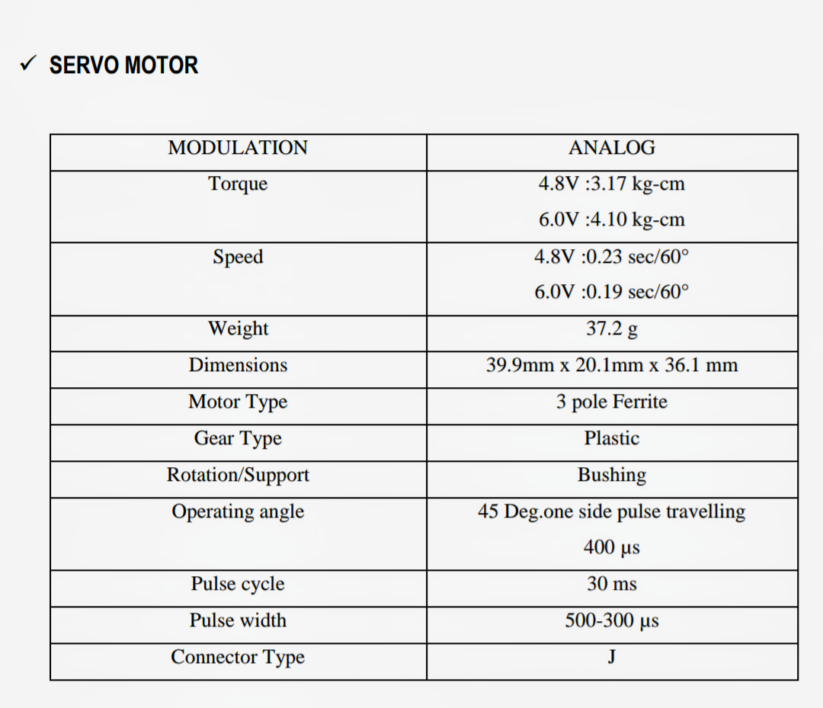**General Instructions**

1. Text should be printed on front and correct side of the watermark on quality bond paper

**Paper size**- A4, 70 to 85 gsm paper

**Margins**: Top-1”, Bottom-1”, Left -1.5”, Right- 1”

1. **Font:** Times New Roman
   * + Font Size For Chapter heading -14(Bold uppercase)
     + Font Size For main titles -12(Bold uppercase)
     + Font Size For Subtitles -12(Bold Title case)
     + Font Size For Text Matter -12
     + Line Spacing -1.5 Lines
     + **Figure/Photograph Caption:** Figure/Photo/Graph should be Centrally aligned to the page. Figure/Photograph caption should be below the Figure/Photography, left align to Figure/Photo/Graph in Title case, 10 TNR, Bold.
     + **Table Caption:** Table should be Central aligned to page. Table caption should be above the Table, center align to Table in Title case, 10 TNR, Bold.

* Figure/Table/Photograph Should Be Numbered Chapter Wise As Fig 1.1, 1.2, 2.1
* **Text:** Main Title No’s should be 1.1, 1.2 etc for chapter no 1, 2.1 2.2 for chapter 2 etc. Subtitle 1.1.1, 1.1.2 etc.
* Reference of Figure Should Be Given In Text Matter
* Total Number of Typed Pages Shall be minimum 40

1. **Students are supposed to be encouraged to participate in inter and intra college level, University level and National level project competitions and demonstrations.**
2. **References**

**For Books:-**

Name of Author, "Title of Book", Name of Publisher, Vol. No., Year of Publication,

Page no.

**Example:**

Singiresu Rao, "The FEM in Engineering", BH Publication, 3rd Edition,1998, PP-  
 22-30